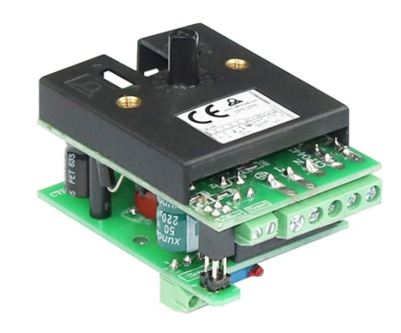

**Type 2PE2P6**

**Electronic thermostat, multi range, control and manual reset action, for incorporation, Pt100 sensor.**

Main features: This electronic thermostat for incorporation has been designed to replace electromechanical thermostats.

Action: On-Off.

Temperature sensor: Pt100.

Temperature ranges: 30 - 110°C; 50 - 200°C; 50 - 300°C; 100 - 400°C; 100 - 500°C.

Power supply: 180 to 240V, 50Hz or 60Hz.

Relay output: SPNO, 16A 250V resistive, 100,000 cycles.